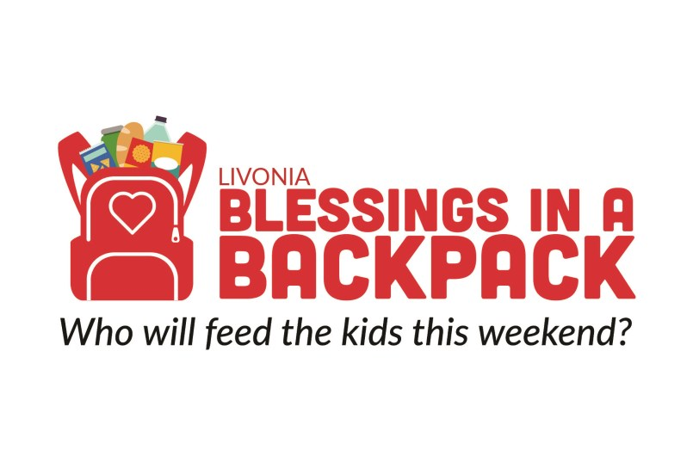

6TH ANNUAL
BOWLING FOR BACKPACKS – LIVONIA
Merri-Bowl Lanes, 30950 Five Mile Road, Livonia, MI

Saturday $20 / $10 non-bowlers includes
November 23, 2019 2 Hours of Bowling
2:00 – 4:00 pm Shoe rental
Registration starts at 1:00pm 2 slices of Pizza and Pop
Please register online prior to event!
Many Wonderful Raffle Items, 50/50 Raffle
Raffle, Playing Card Draw,
50/50 Raffle

Purchase tickets at https://guestli.st/624162
or visit our website at www.biablivonia.org

For special accommodations, or information contact us at www.biablivonia.org
Audra Rons at 248-701-3277 or audrarons@gmail.com or
Jan Wilson at 248-505-3778 or wilsonjm101@gmail.com

Proceeds to benefit Blessings in a Backpack – Livonia for the children of Livonia Pubic Schools

Blessings in a Backpack is a non-profit organization 501(c)(3). All donations are tax deductible.
This organization provides food each weekend to at-risk children who qualify for the Livonia Public Schools
Free or Reduced Fee lunch program.

